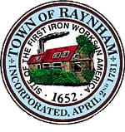

CAPITAL PLANNING COMMITTEE

TOWN OF RAYNHAM
558 South Main Street
Raynham, Massachusetts 02767

CAPITAL PLANNING COMMITTEE MEETING

Monday, October 17, 2022 at 6:00 PM

Raynham Town Hall
Sullivan Conference Room

AGENDA

- Discussions and Deliberations on FY 2023 Capital Requests for the Fall Special Town Meeting of November 15, 2022 to possibly include hearings with representatives of the following departments: Cemetery, COA, Fire, Highway, Park & Recreation, Police, and Sewer Enterprise
- General business and correspondence
- Adjournment

Brendan Loftus, Chairman

