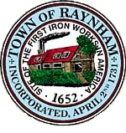

FINANCE COMMITTEE

TOWN OF RAYNHAM
558 South Main Street
Raynham, Massachusetts 02767

FINANCE COMMITTEE MEETING

Wednesday, March 18, 2026 at 6:00 PM

Bridgewater Raynham Regional High School
415 Center Street
Bridgewater, MA
Lecture Hall

AGENDA

- Joint meeting with the Bridgewater-Raynham Regional School Board and Bridgewater and Raynham Town officials, for an informational workshop to report on the CliftonLarsonAllen (CLA) financial assessment of the Bridgewater-Raynham Regional School District (BRRSD) contracted by the Towns.
- Adjournment
Gilbert L. Alegi, Chairman

