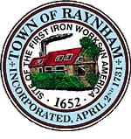

FINANCE COMMITTEE

TOWN OF RAYNHAM
558 South Main Street
Raynham, Massachusetts 02767

FINANCE COMMITTEE MEETING

Tuesday, January 30, 2024 at 6:00 PM

Raynham Town Hall
Sullivan Conference Room

AGENDA

- Discussion of FY 2025Budget Process & Forms
- Discussion of FY 2025 Budget Challenges
- General business and correspondence
- Adjournment
Gilbert L. Alegi, Chairman

