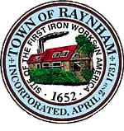

FINANCE COMMITTEE

TOWN OF RAYNHAM
558 South Main Street
Raynham, Massachusetts 02767

FINANCE COMMITTEE MEETING

Tuesday, February 2, 2024 at 6:00 PM

Raynham Town Hall
Sullivan Conference Room

AGENDA

- Discussion of FY 2025 budget process and forms
- Discuss department liaisons
- General business and correspondence
- Adjournment
Gilbert L. Alegi, Chairman

