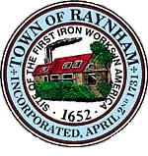

FINANCE COMMITTEE

TOWN OF RAYNHAM
558 South Main Street
Raynham, Massachusetts 02767

FINANCE COMMITTEE MEETING

Tuesday, March 19, 2024 at 6:00 PM

Raynham Town Hall
Sullivan Conference Room

AGENDA

- Review FY 2025 budgets received to date.
  - Highway, Parks and Grounds
  - Employee Benefits.
- General business and correspondence.
Gilbert L. Alegi, Chairman

