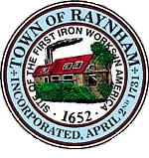

FINANCE COMMITTEE

TOWN OF RAYNHAM
558 South Main Street
Raynham, Massachusetts 02767

FINANCE COMMITTEE MEETING

Wednesday, March 6, 2024 at 6:00 PM

Raynham Town Hall
Sullivan Conference Room

AGENDA

- Review FY 2025 budgets received to date.
  - 6:00 – Fire Department
  - 6:20 – Police Department
  - 6:40 – Library
- General business and correspondence.
Gilbert L. Alegi, Chairman

