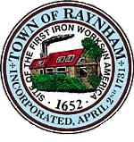

FINANCE COMMITTEE

TOWN OF RAYNHAM
558 South Main Street
Raynham, Massachusetts 02767

FINANCE COMMITTEE MEETING

Tuesday, April 30, 2024 at 6:00 PM

Raynham Town Hall
Sullivan Conference Room

AGENDA

- Vote to Recommend / Not Recommend money articles in ATM warrant.
- General business and correspondence.

Gilbert L. Alegi, Chairman

