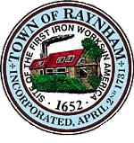

FINANCE COMMITTEE

TOWN OF RAYNHAM
558 South Main Street
Raynham, Massachusetts 02767

FINANCE COMMITTEE MEETING

Wednesday, July 13, 2022 at 6:00 PM

Raynham Town Hall
Sullivan Conference Room

AGENDA

- Review and approve year-end transfers.
- General business and correspondence.

Gilbert L. Alegi, Chairman

