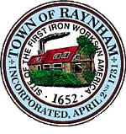

ANIMAL CONTROL/ANIMAL SHELTER COMMITTEE

TOWN OF RAYNHAM
558 South Main Street
Raynham, Massachusetts 02767

MEETING OF THE ANIMAL CONTROL/ANIMAL SHELTER COMMITTEE

Thursday, March 16, 2023 at 4:00 PM

Gymkhana Building
2217 King Phillip Street

AGENDA

- Tour of Gymkhana Facility
- Discussion of Draft Mission, Policies, Procedures, and Plan of Action for Animal Control Shelter and Usage Statistics for Animal Control Activities
- General business and correspondence
- Adjournment
Gregory W. Barnes, Town Administrator

