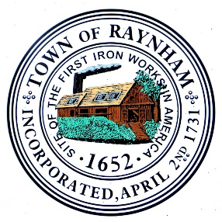
Raynham Capital Planning Committee Meeting

Raynham Town Hall
558 South Main Street
Raynham, Ma. 02767

September 28, 2021, 6:30 PM
and
September 29, 2021, 6:30 PM

September 28th Agenda

- Discussion/Action - FY2022 Capital Requests
- General business and correspondence
- Adjournment

September 29th Agenda

- Discussion/Action - FY2022 Capital Requests
- General business and correspondence
- Adjournment

Brendan Loftus
Chair

