TOWN OF RAYNHAM

Selectmen and Board of Health
558 South Main Street
Raynham, MA 02767
Tel: (508) 824 - 2766
Tel: (508) 824 - 2707
Fax: (508) 824 -1540
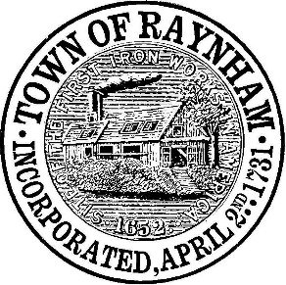

The following is a list of COVID-19 test locations within a 10-mile radius of the center of Raynham as of 10/21/2020. If you are experiencing COVID-19 symptoms or have been exposed to someone with COVID-19, it is highly recommended that you get tested. Please call your primary care physician or the Raynham Board of Health at (508) 824 – 2766 if you have any questions.

Raynham Taunton Pediatrics
876 Broadway
Raynham
(508) 824 - 9500

CVS Broadway
252 Broadway
Raynham
(508) 824 - 8621

CVS RT44
266 Route 44
Raynham
(508) 824 - 1361

Health Express Raynham
106 New State Hwy
Raynham
(781) 626 - 5500

Morton Hospital
88 Washington Street
Taunton
(508) 828 - 7000

CVS Washington Street
7 Washington Street
Taunton
(508) 821 - 5605

CVS County Street
675 County Street
Taunton
(508) 823 - 5376

Compass Medical Urgent Care
8 Commerce Blvd #101
Middleborough
(774) 260 - 9100

CVS Bridgewater
9-19 Summer Street
Bridgewater
(508) 697 - 6946

CareCentral Urgent Care Bridgewater
233 Broad Street
Bridgewater
(508) 807 - 5265

CVS West Bridgewater
2 West Center Street
West Bridgewater
(508) 588 - 8050

CVS North Easton
689 Depot Street
North Easton
(508) 238 - 0604

CareCentral Urgent Care North Easton
682 Depot Street
North Easton
(508) 297 – 1665

