VOLUNTEERS NEEDED!
RAYNHAM’S EARTH DAY PROJECT
HELP RESTORE GUSHEE POND
TO ITS NATURAL BEAUTY
SATURDAY, APRIL 22ND
Early Birds - 8:00 a.m.
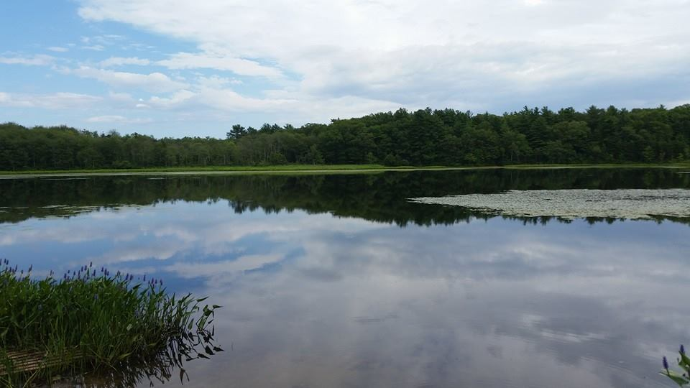
(Come When You Can)
GUSHEE POND
(LOCATED OFF TITICUT ROAD)
JOIN US AND BE PART OF THE SOLUTION RAYNHAM TOGETHER MAKES RAYNHAM STRONG!
(Any extra rakes, shovels, etc. appreciated)

