TOWN OF RAYNHAM

Selectmen and Board of Health
558 South Main Street
Raynham, MA 02767
Tel: (508) 824 - 2766
Tel: (508) 824 - 2707
Fax: (508) 824 -1540

April 28, 2021

Taunton Regional Vaccination Site - Opening May 1st
Raynham residents are invited to make an appointment to get vaccinated at the regional vaccination site opening at the Taunton Holiday Inn located at:
700 Myles Standish Boulevard, Taunton.

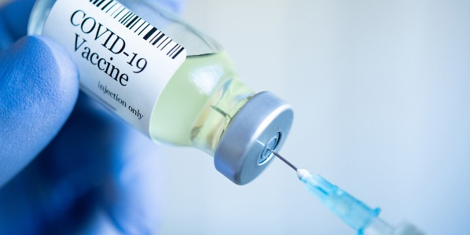

Appointments will be available at the Taunton location on Tuesdays and Saturdays. The direct link to make an appointment is below:
https://home.color.com/vaccine/register/taunton?calendar=5268454a-afb3-4113-8e6c-8322f5b7d7ff

